16/12/2019

TVNP

NAWG

Local Wildlife Site

Site name: Billingham Beck Saltmarsh South
- OS National Grid Ref: NZ 476-203
- Land ownership: Inter Terminals (Riverside Site)
- Contact: David Lyon (Senior Terminal Manager)
- District: Stockton-on-Tees Borough Council
- Qualifying feature: Saltmarsh
- Tees Valley Nature Partnership Qualifying criteria code: C1
- Most recent site survey date: 17 July 2018
- Research and survey undertaken by INCA (Mike Leakey and Ian Bond)
- Location of site details and evidence: INCA Habitat Assessment Project, INCA office
- Date of LWS recommendation by Tees Valley Nature Partnership: 18/12/2019
- Recommended management: Non intervention
- Recent management history: None
- Site in positive management: Yes (17/07/2018)

Site boundary

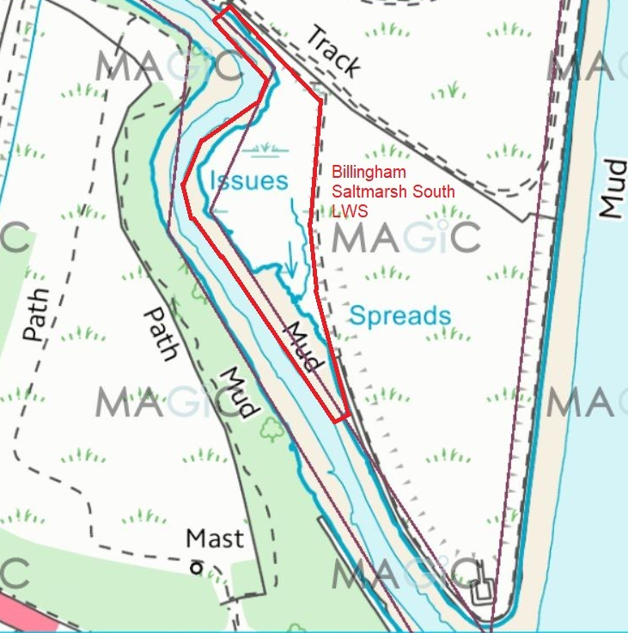

Site description:
An area of saltmarsh extending to approximately 0.66 Ha on the northern bank of Billingham Beck, 300m upstream from its confluence with the River Tees. Zonation apparently confined to mid and upper saltmarsh communities. Vegetation is dominated by Sea Couch Elytrigia atherica (Dominant) along with Red Fescue Festuca rubra (Frequent). Other key indicator species comprise of Saltmarsh Grass Puccinellia spp. (Rare), Sea Arrowgrass Triglochin maritima (Rare), Spear-leaved Orache Atriplex hastata (Rare), Grass-leaved Orache Atriplex littoralis (Rare), Sea Beet Beta vulgaris (Rare) and Sea Aster Aster tripolium (Rare). Percentage of bare ground: <2%.
The habitat is used as a high-water haul-out by small numbers of both common and grey seals, predominantly in summer.
The saltmarsh habitat lies outside the Inter Terminals operational site.

Site location

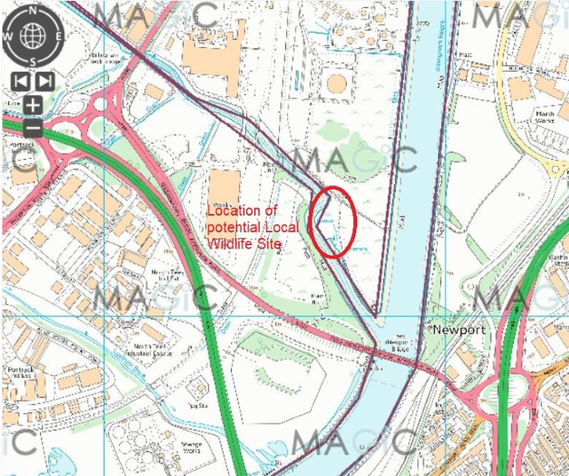

End

